

***INSTITUTE OF INFORMATION TECHNOLOGY***

***JAHANGIRNAGAR UNIVERSITY***

**Lab Exam :** 01

**Submission Date :** 04/01/2022

**Course Tittle :** Database Management System Lab

**Course Code :** ICT - 2204

**Submitted To Submitted By**

Manan Binth Taj Noor Md. Shakil Hossain

Lecturer Roll – 2023

IIT – JU 2nd year 2nd Semester

IIT – JU

Create Customer Table

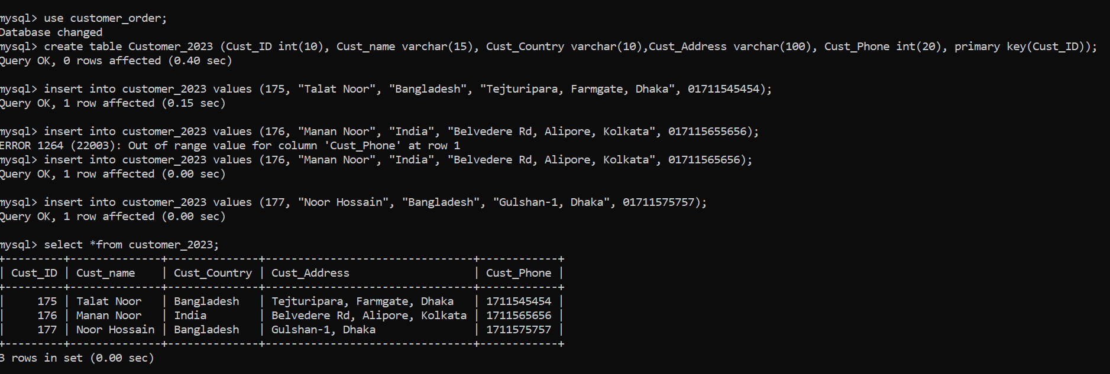

Create Order Table

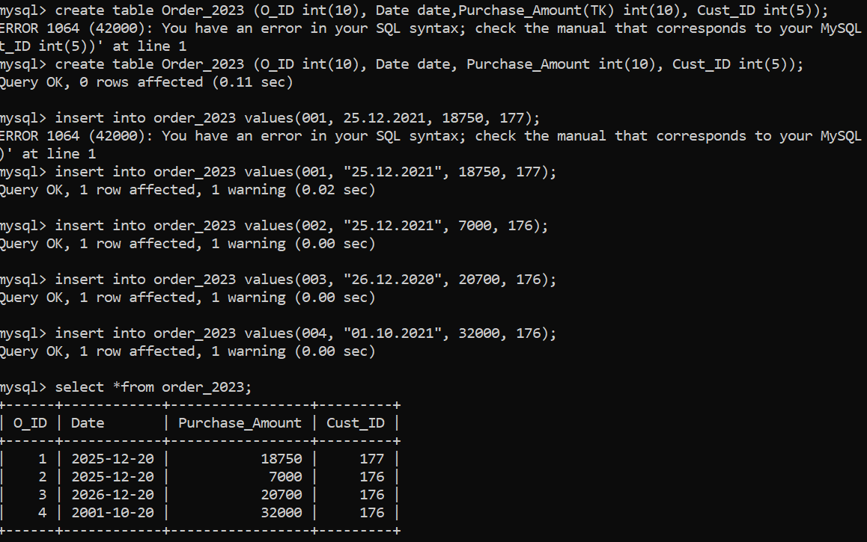

Create Item Table

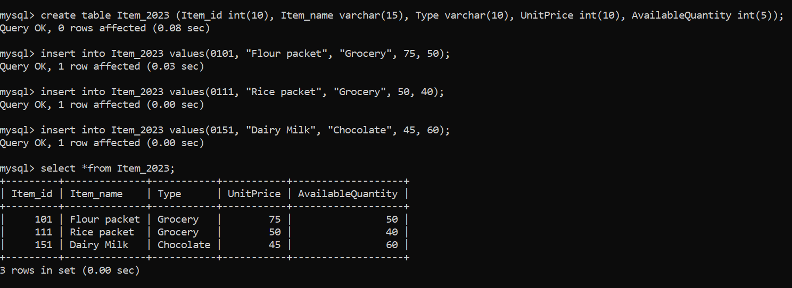

Create Ord Item Table

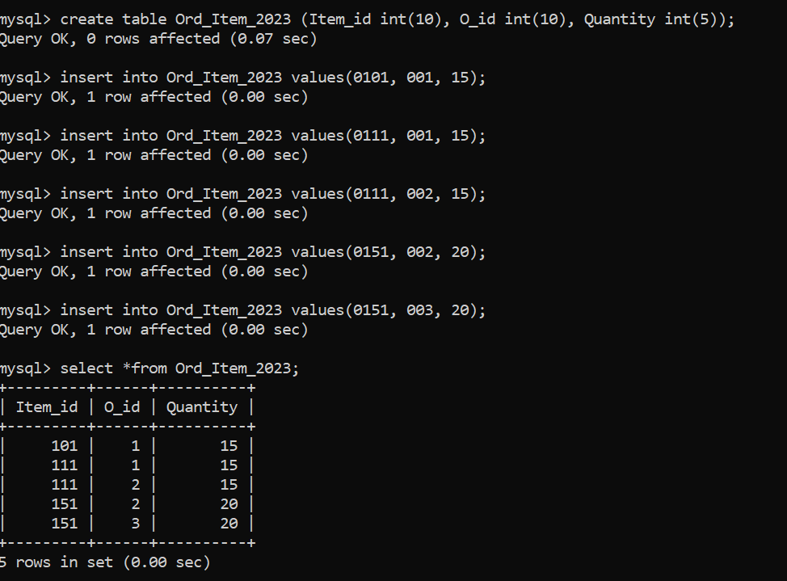

**Answer 1**

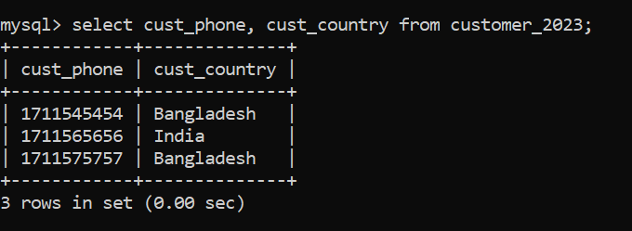

**Answer 2**

**Answer 3**

**Answer 4**

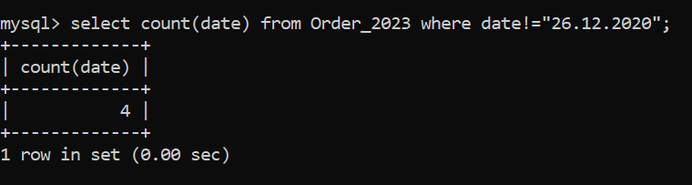

**Answer 5**

**Answer 6**

**Answer 7**

**Answer 8**

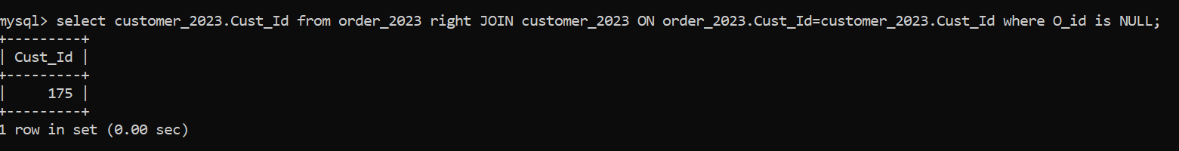

**Answer 9**

**Answer 10**